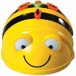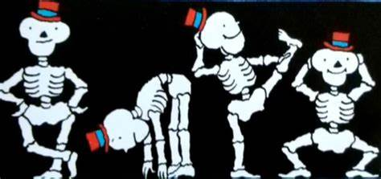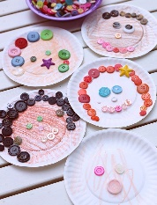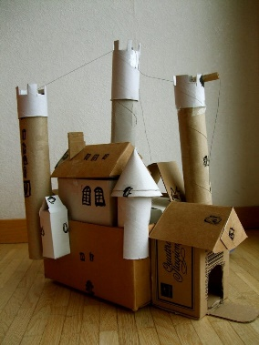

**Marvellous Me**

Understanding the world

We will be looking at; skeletons/ parts of the body, changes since a baby and homes.

Technology/Computing

Children will be learning how to program simple instructions using the BeeBots.   
Child will also be encouraged to photograph any work they are proud of so we can display this in our classroom.

PSED

We will be discussing rules and routines during circle time.

As our topic is Marvellous Me, we will be talking a lot about ourselves and our families.

Reminders

Please can you make sure PE kits are in school all week.   
Please try to read with your child daily.

R.E

We will be learning about people who belong to religious communities.

P.E

In P.E we will be looking at different ways to move to music.

Expressive Art and Design

We will be creating self-portraits  
using different materials.

In expressive arts children will begin to introduce narrative to their play by acting out stories we have read in class.

In Music we will be learning to sing nursery rhymes and action songs.

Design and Technology

We hope to construct our   
homes using everyday  
materials. If you have any   
cereal boxes we could  
use, please send them to   
school with your child.

Autumn Term 1